7/17/2026
Submitted By, Prithika BH
192424403
LAB PROGRAMS
DATA HANDLING AND VISUALIZATION
SET 1: Monthly Sales Data
Dataset: Monthly Sales
Month | Sales ($)
January | 15000
February | 18000
March | 22000
April | 20000
May | 23000
Questions
- Create a line chart to visualize the monthly sales. Label the axes and title the chart appropriately.
- Generate a bar chart to display the top-selling products for the year. Label the chart elements.
- Develop a scatter plot to explore the relationship between advertising budget and monthly sales. Explain the insights drawn from the scatter plot.
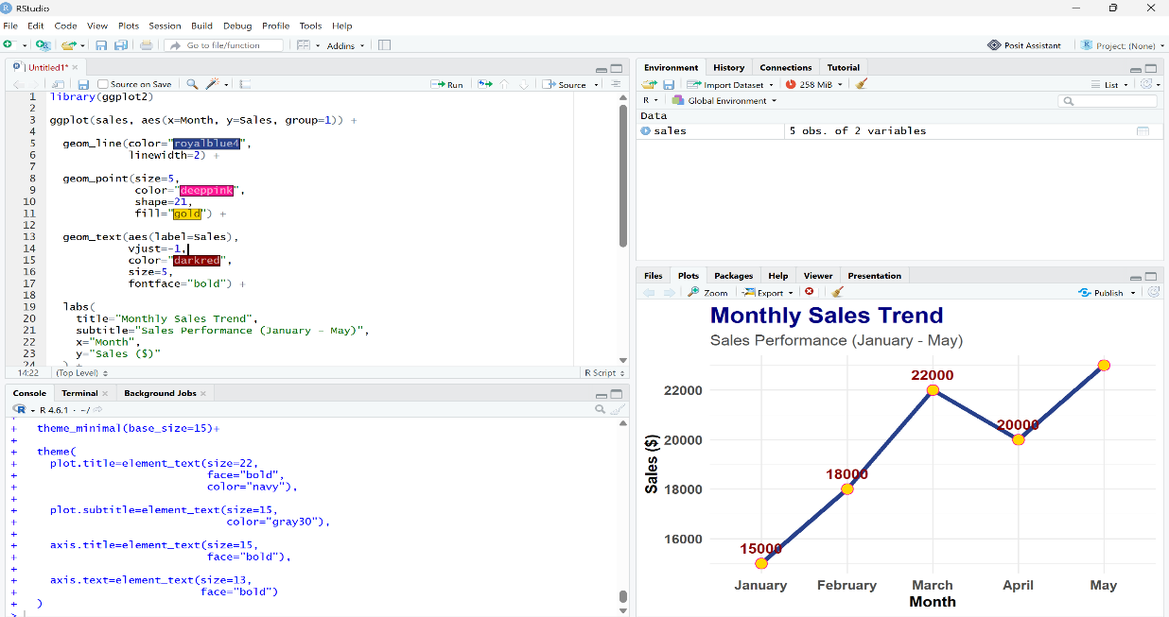
- Build an interactive dashboard combining the line chart and bar chart to allow users to explore sales data interactively.
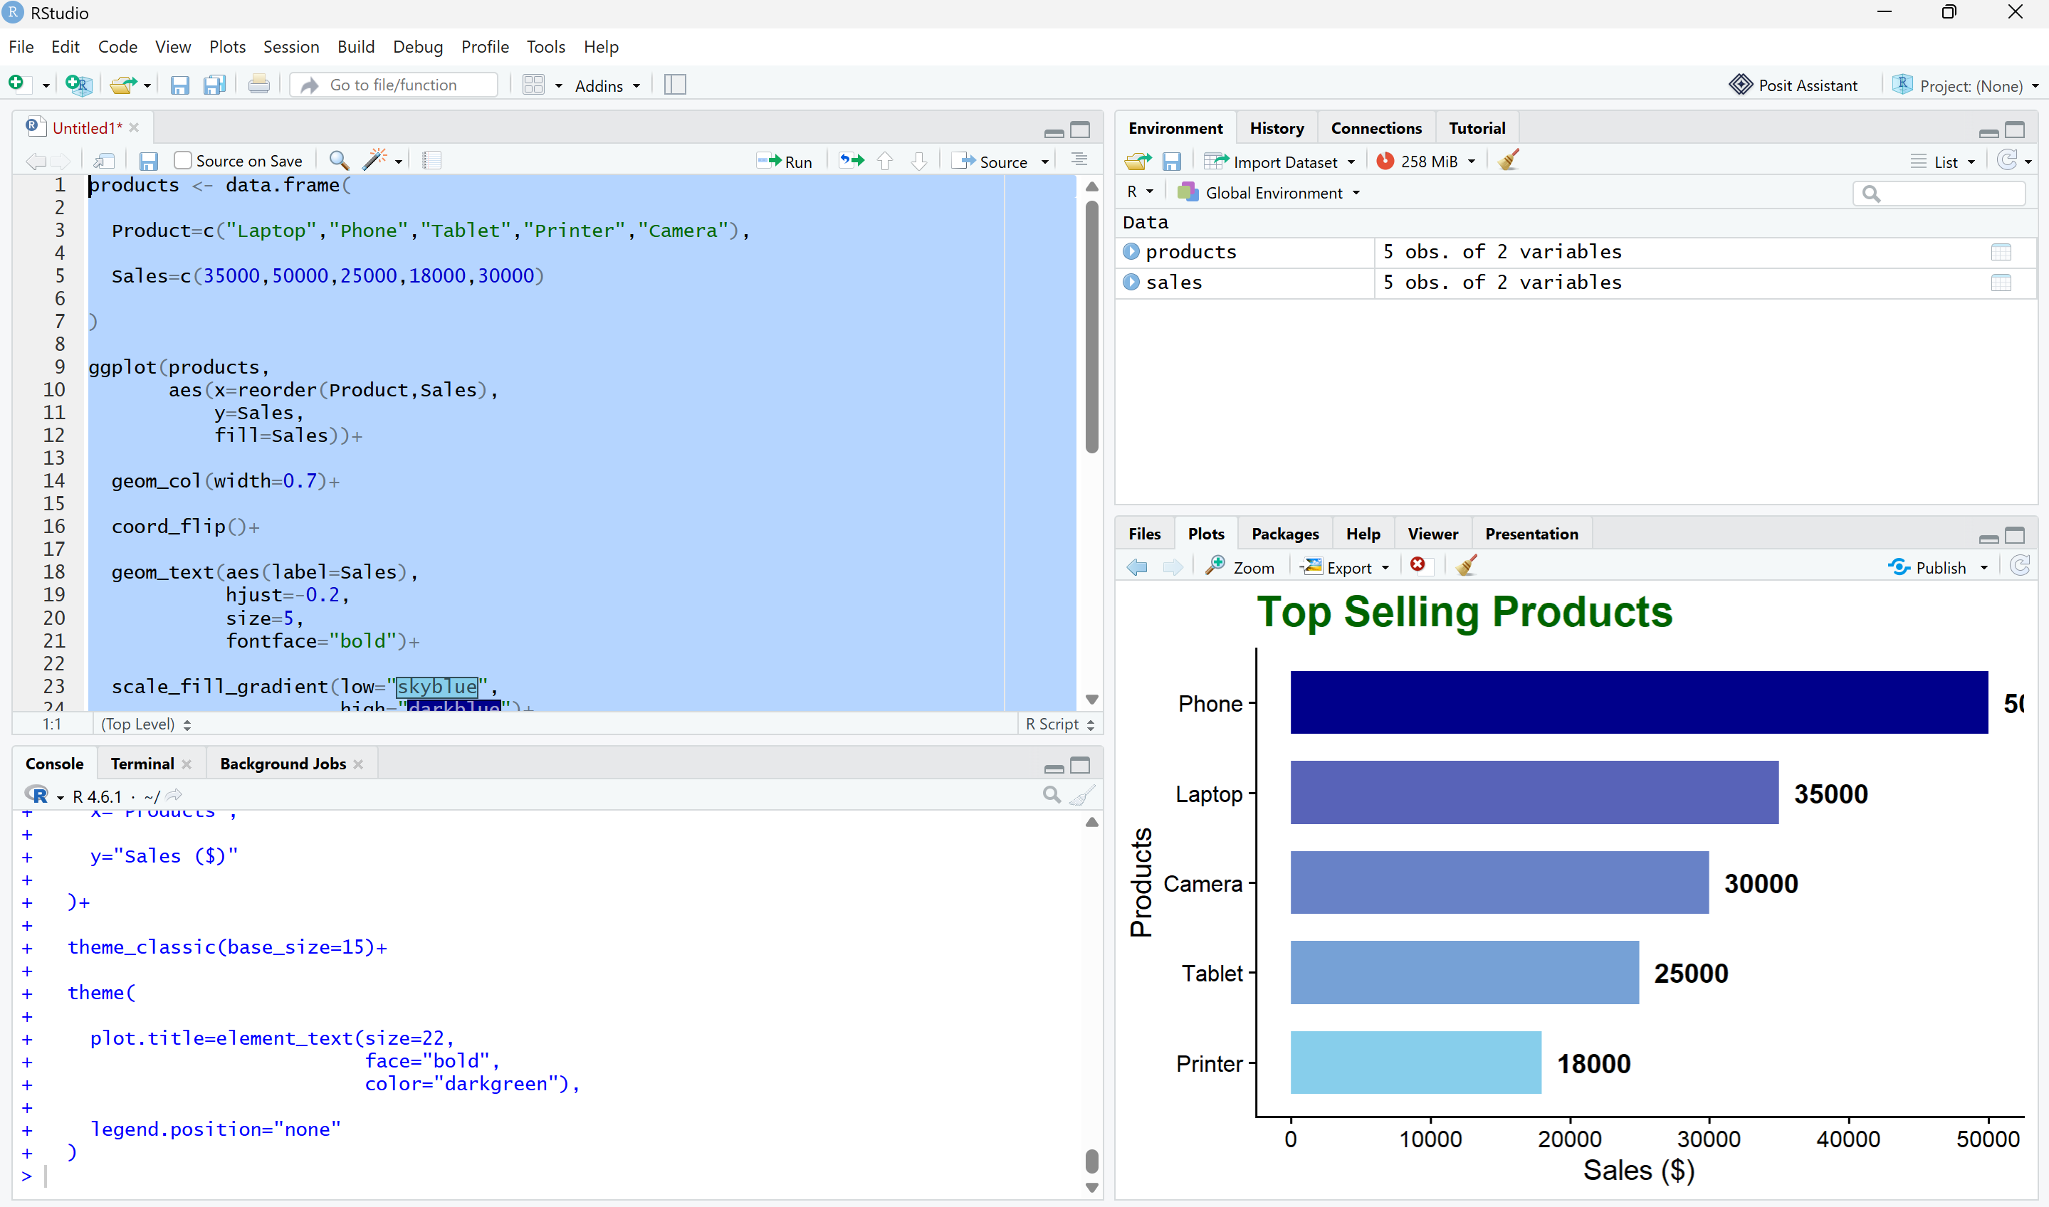
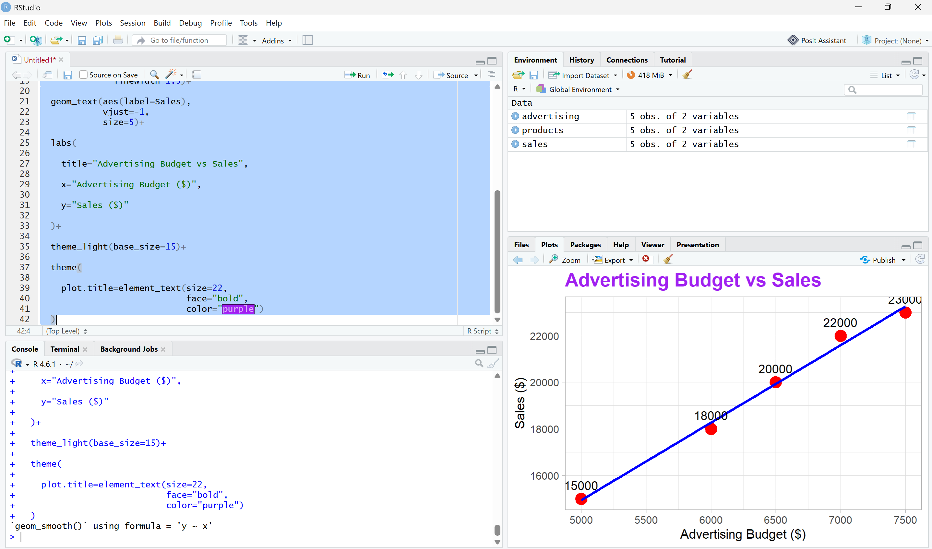

SET 2: Customer Feedback Analysis
Dataset: Customer Satisfaction
Customer ID | Age | Satisfaction Score
1 | 25 | 4
2 | 30 | 5
3 | 35 | 3
4 | 28 | 4
5 | 40 | 5
Questions
- Create a histogram to represent the distribution of customer ages. Label the axes and title the chart.
- Generate a pie chart to display the overall distribution of customer satisfaction scores. Include labels.
- Build a stacked bar chart to visualize the distribution of customer satisfaction scores by age group.
- Develop a word cloud from open-ended customer feedback to identify prevalent customer sentiments.
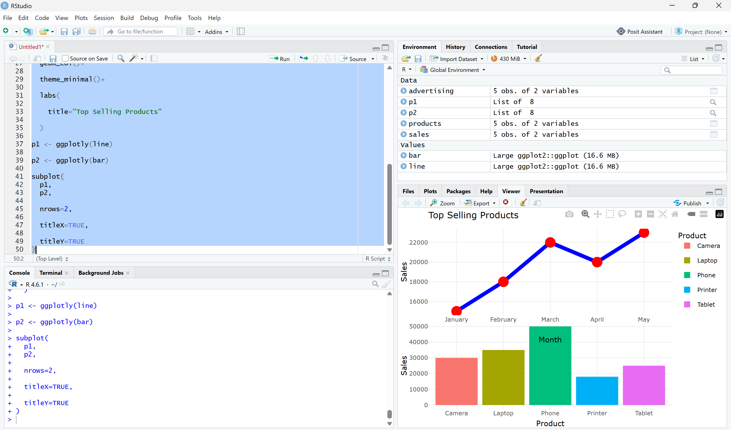
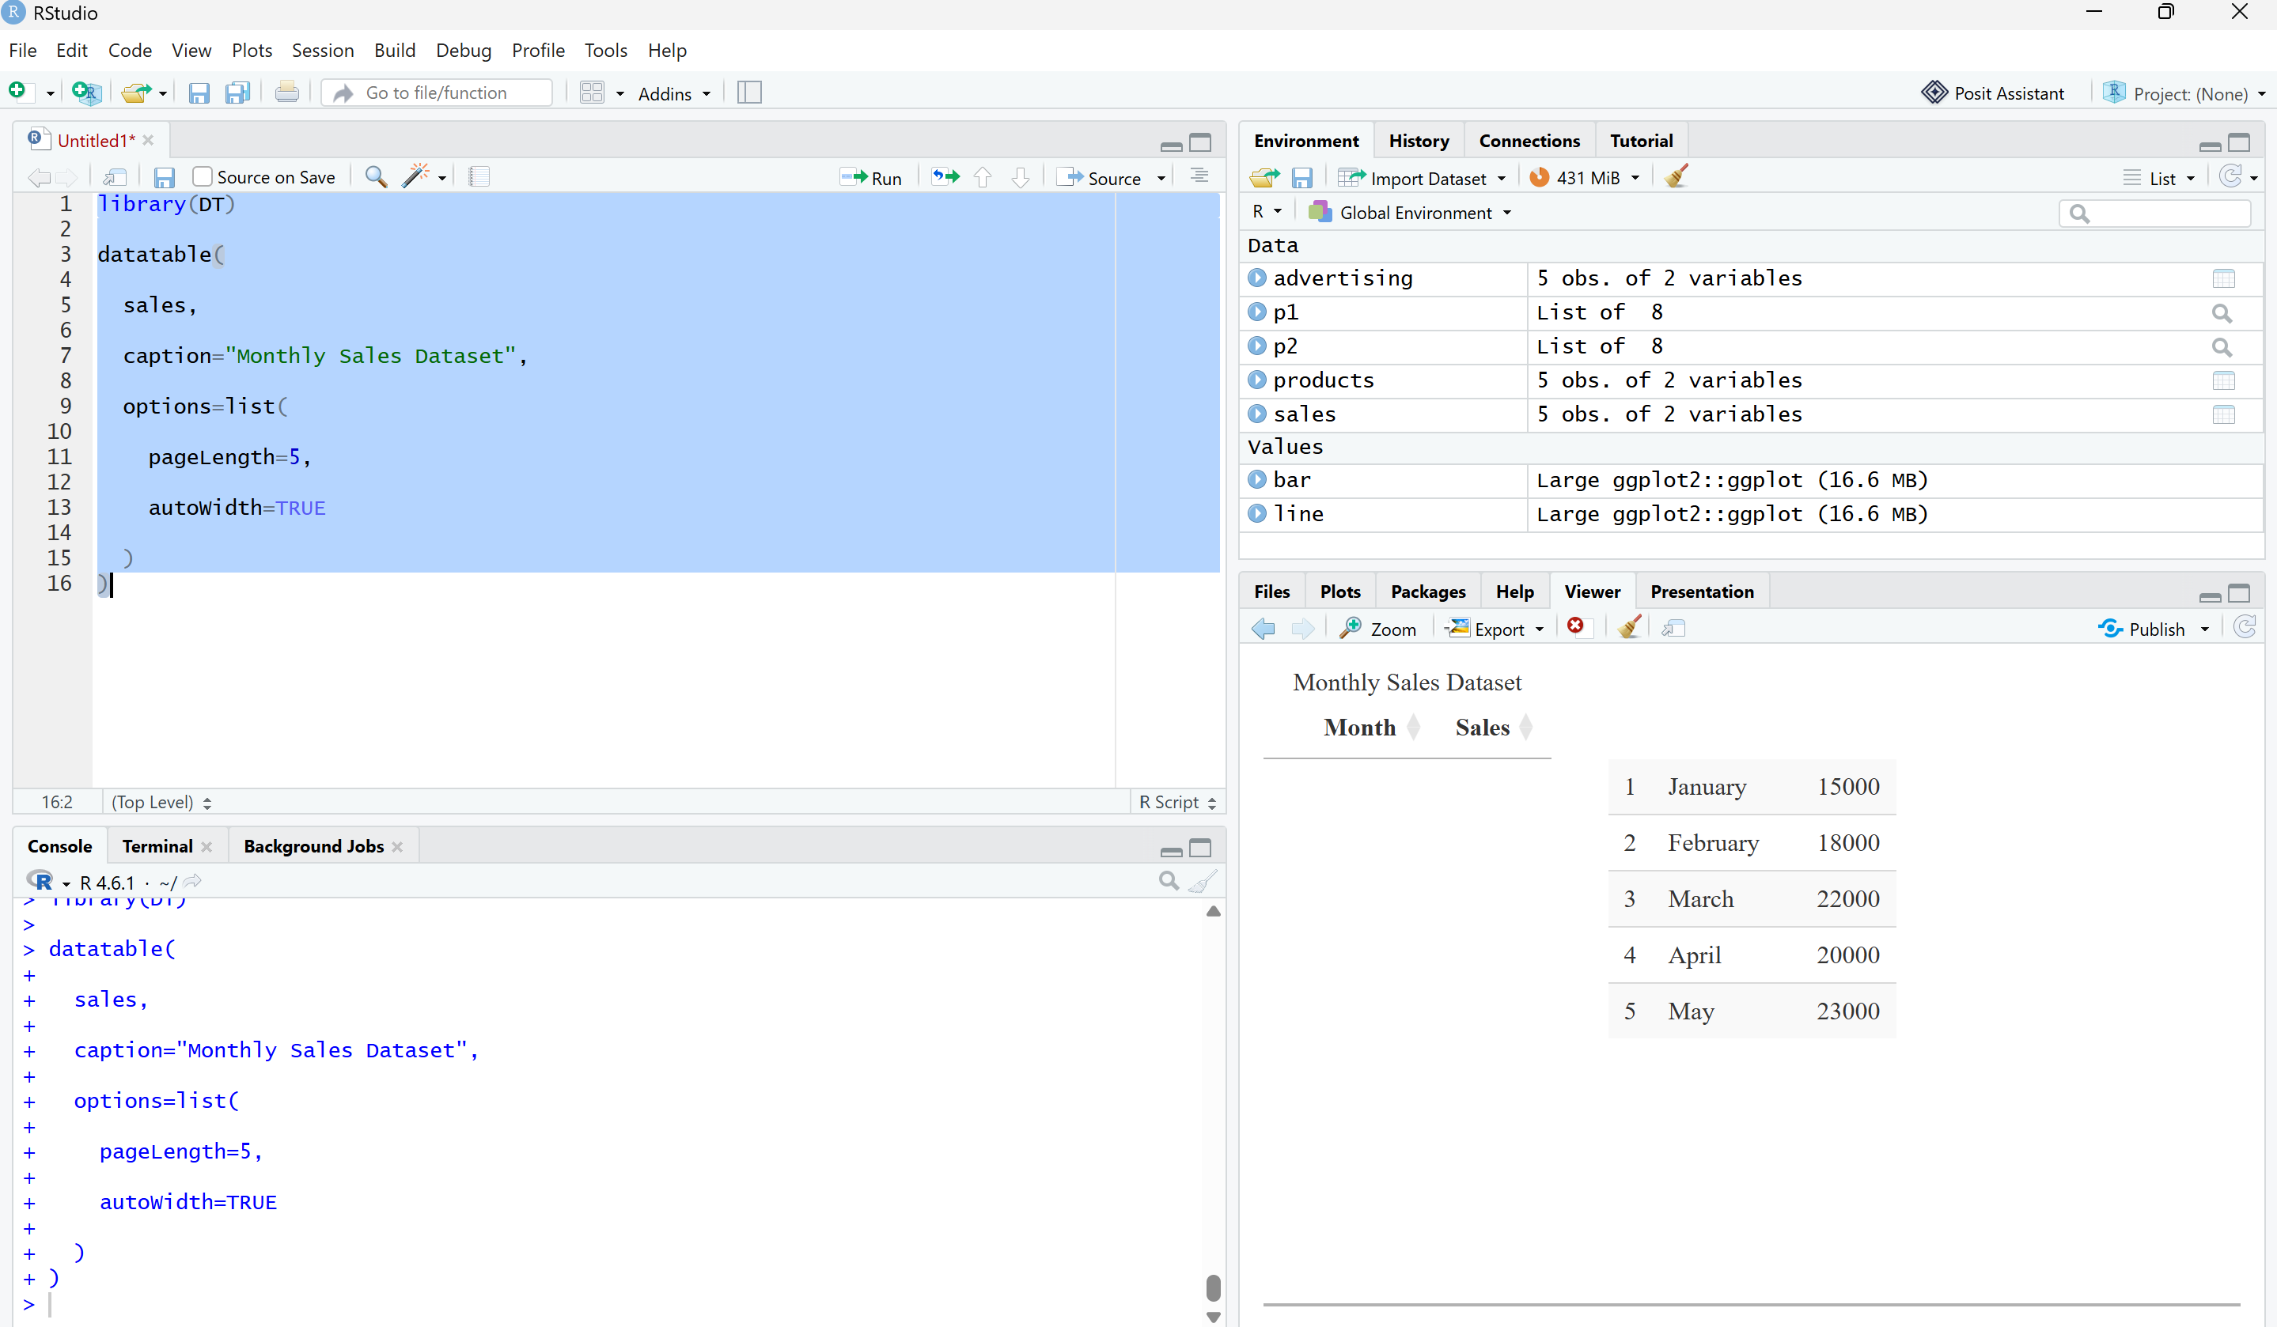
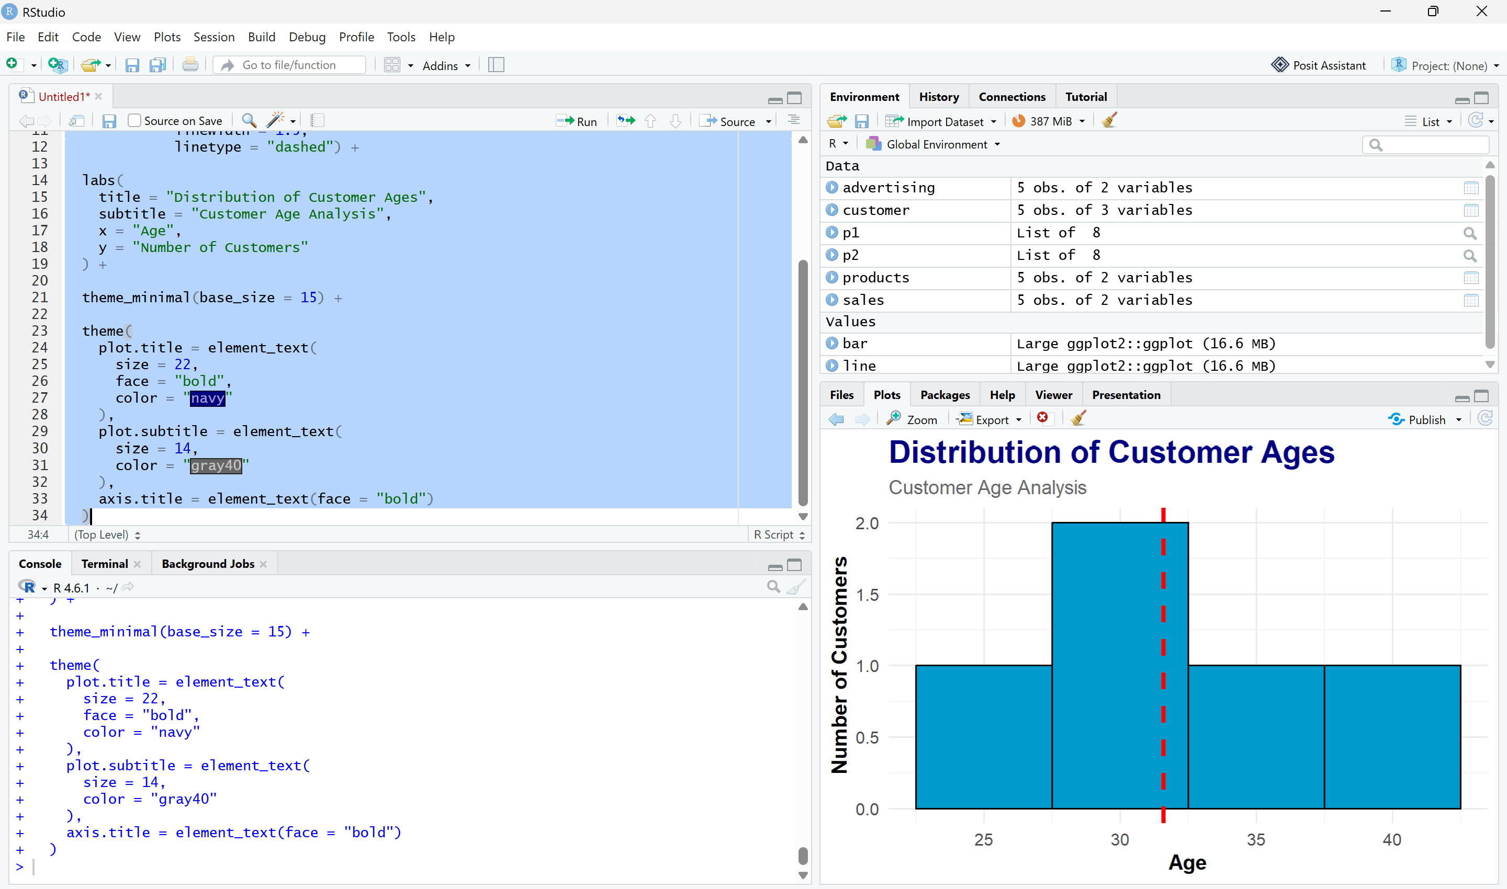
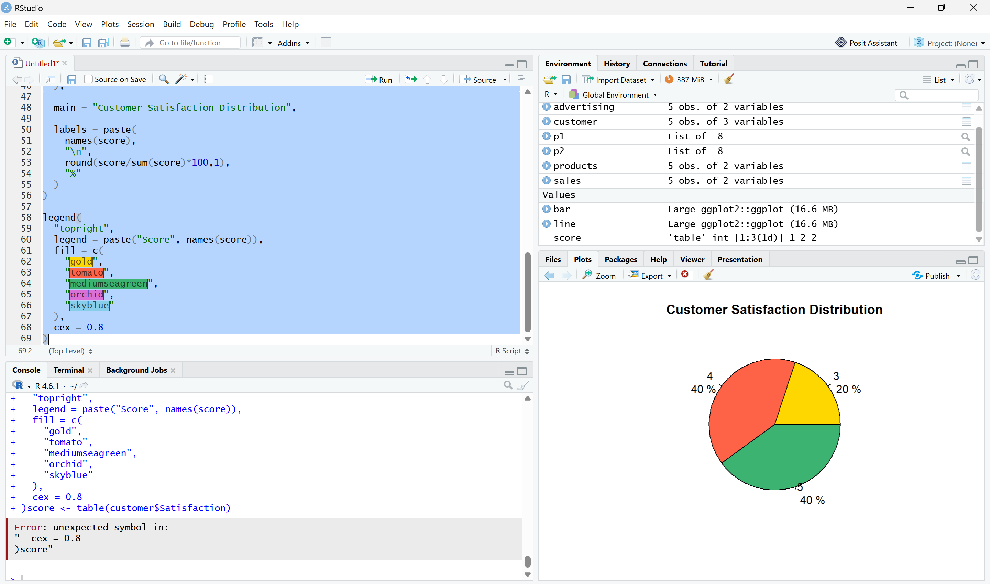
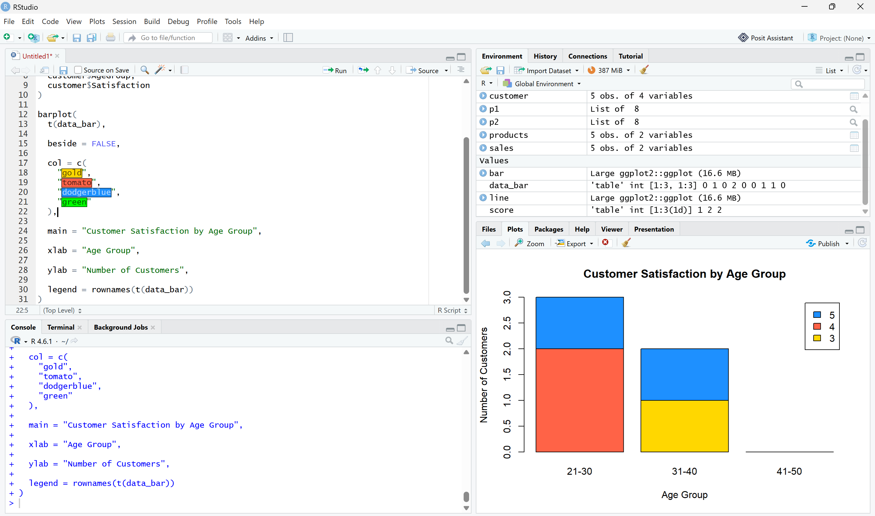
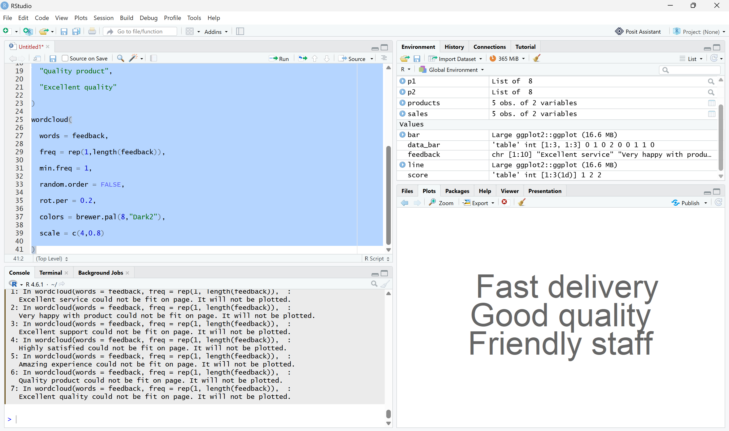
SET 3: Employee Performance Evaluation
Dataset: Employee Performance
Employee ID | Department | Years of Service | Performance Score
1 | Sales | 5 | 85
2 | HR | 3 | 92
3 | Marketing | 7 | 78
4 | Sales | 4 | 90
5 | HR | 2 | 76
Questions
- Create a line chart to visualize the performance trend of employees over time. Include a legend and labels.
- Generate a bar chart showing the distribution of employees across different departments. Label the chart elements.
- Build a scatter plot to analyze the correlation between years of service and performance scores. Explain any insights.
- Develop a Tableau dashboard with the line chart and bar chart for interactive exploration.
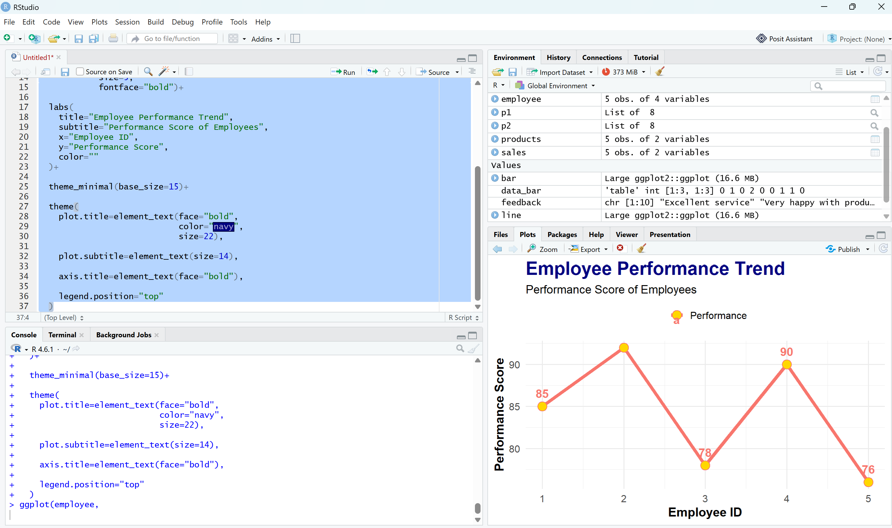
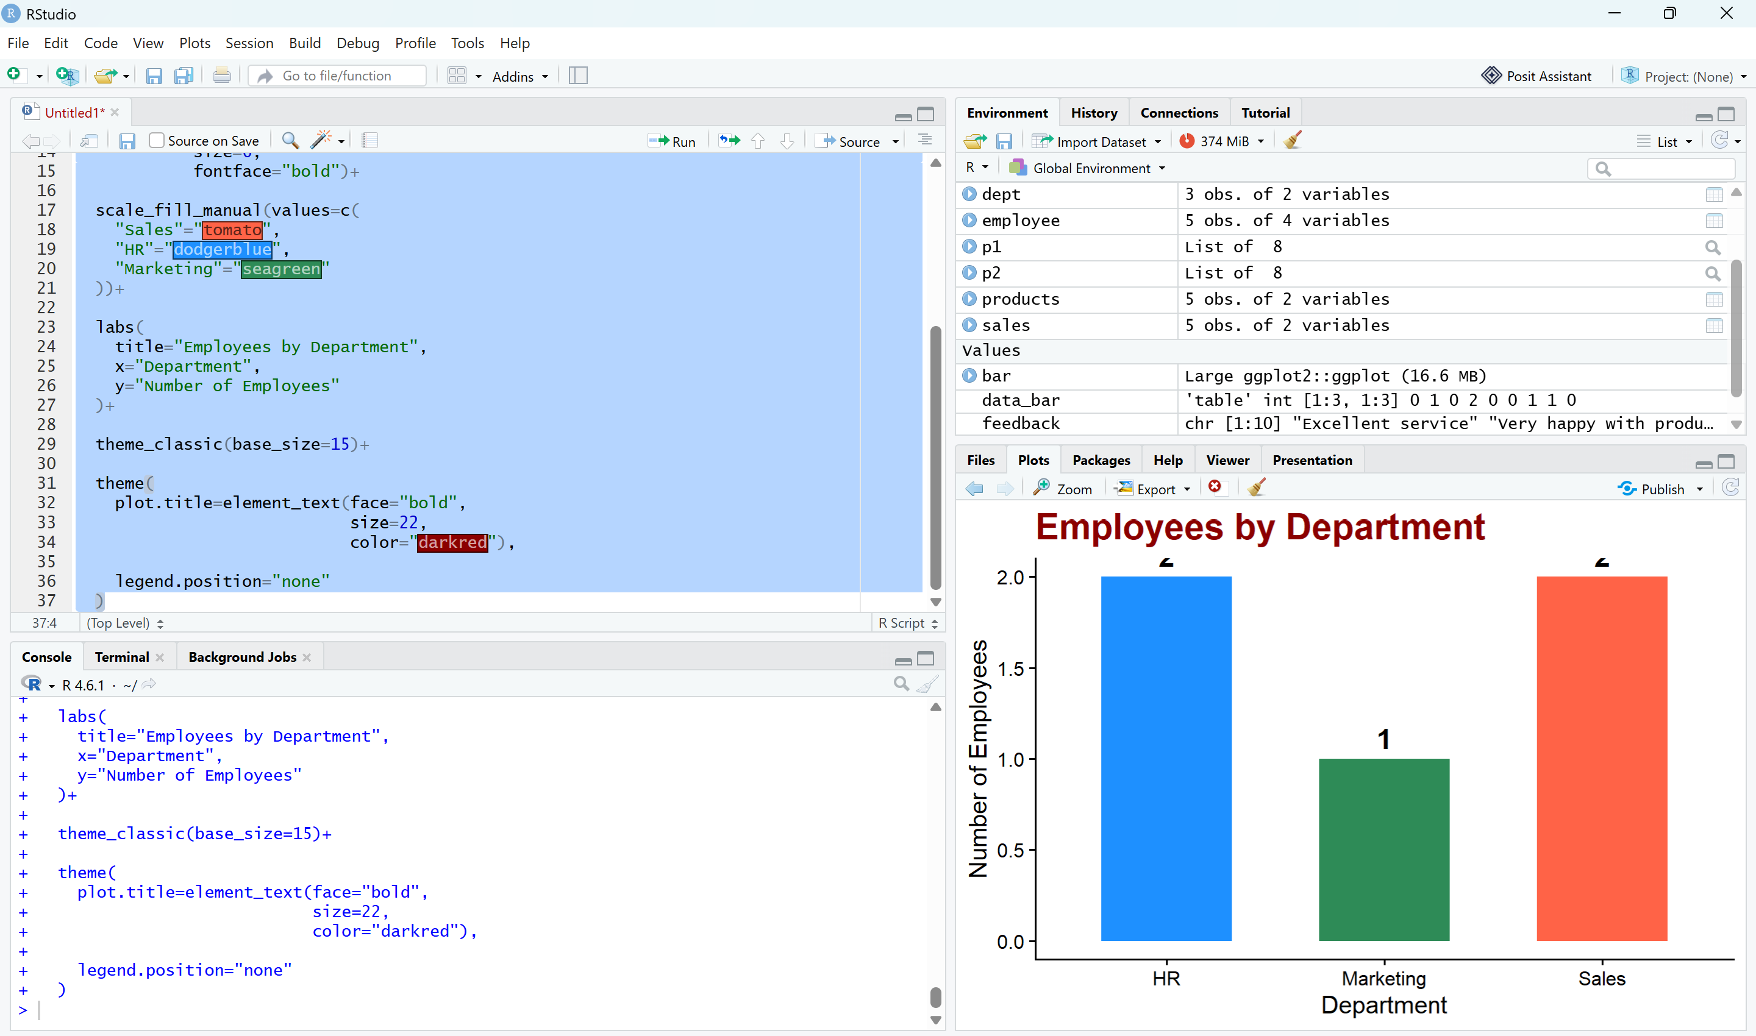
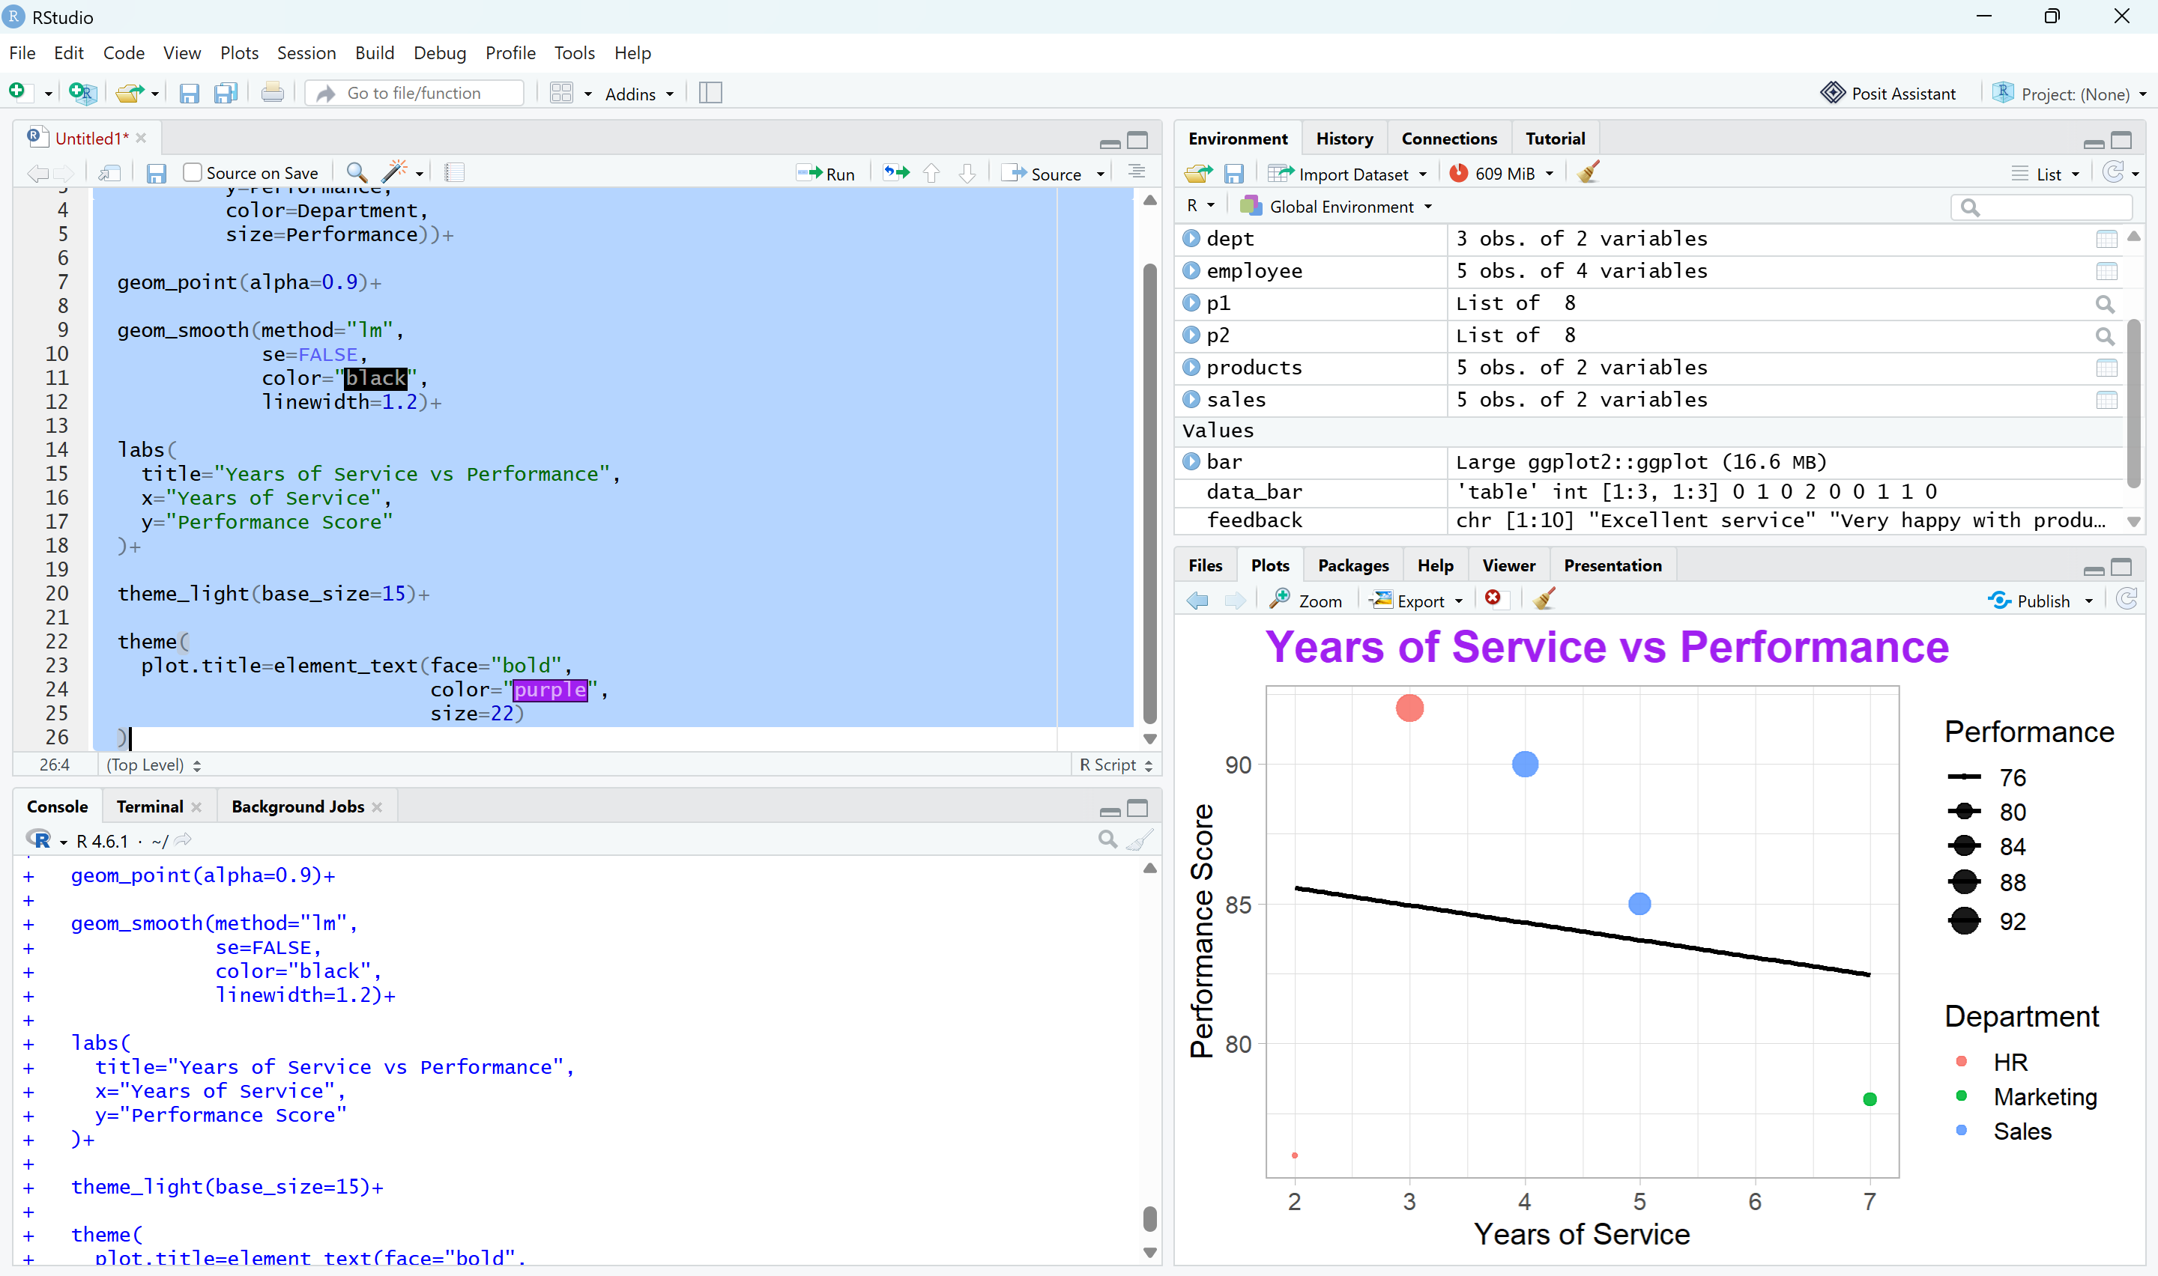
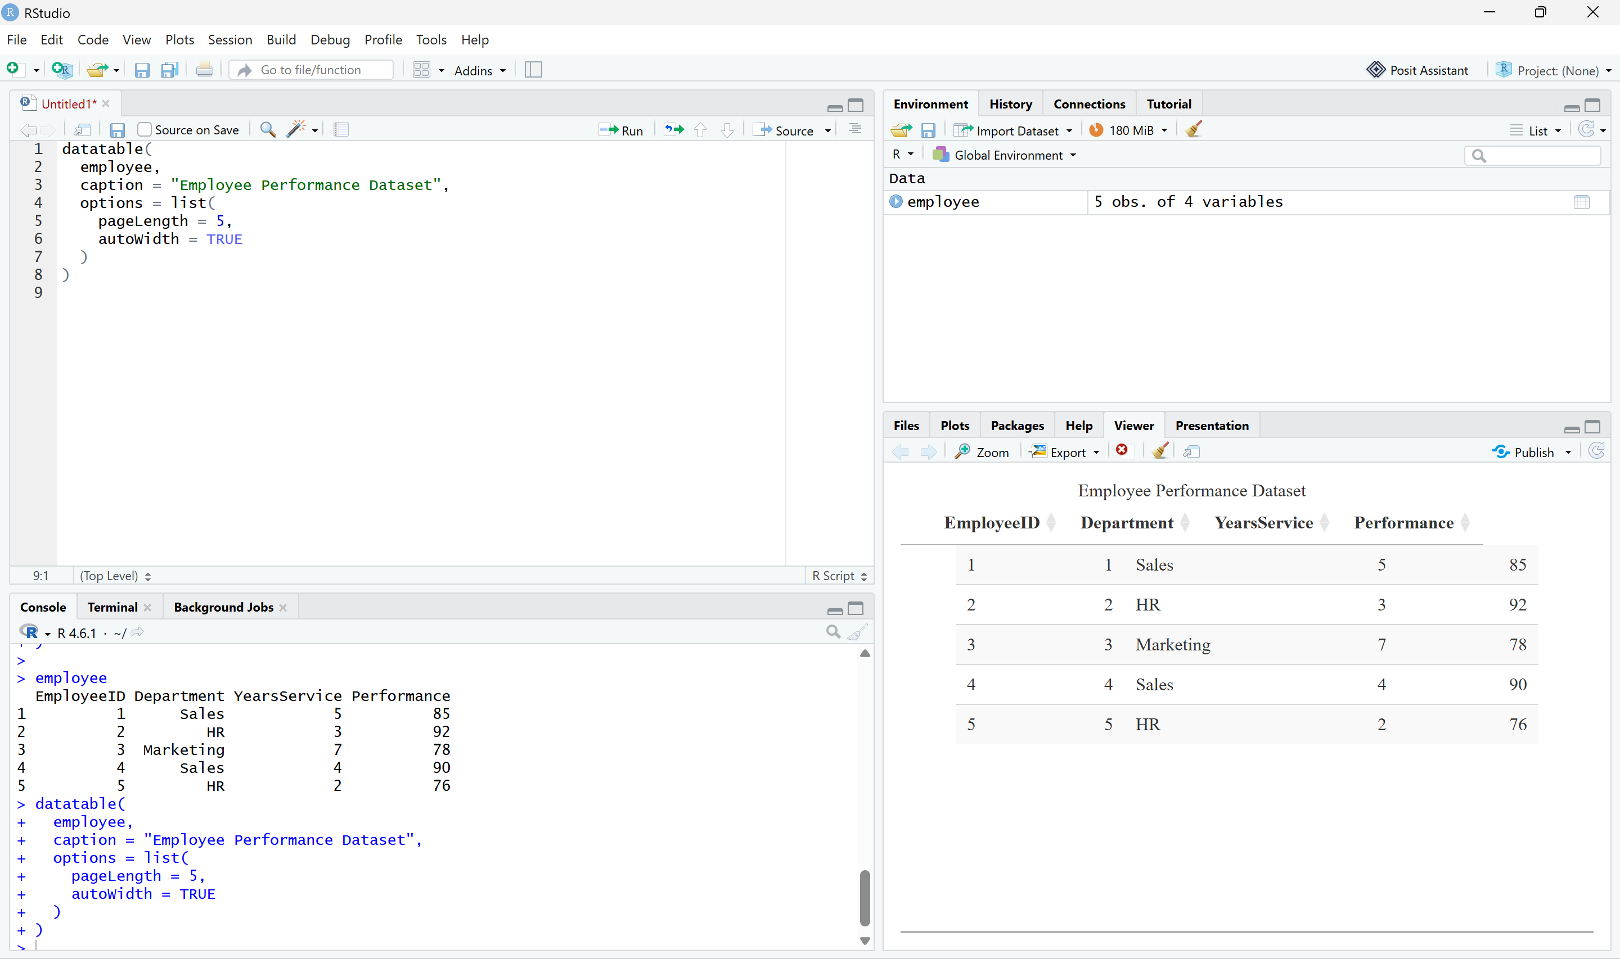

SET 4: Product Inventory Management
Dataset: Product Inventory
Product ID | Product Name | Quantity Available
1 | Product A | 250
2 | Product B | 175
3 | Product C | 300
4 | Product D | 200
5 | Product E | 220
Questions
- Create a bar chart to visualize the quantity of each product in the inventory. Label the axes and title the chart.
- Generate a stacked bar chart to show the quantity of each product within different product categories.
- Build a scatter plot to explore the relationship between product price and quantity available. Explain the findings.
- Develop a Tableau dashboard with the bar chart and stacked bar chart for interactive exploration.
